Decoding Biological Processes

10/8/25

Introduction

Based on “A digit Portrait Into Our Understanding Of The Universe.” (attached) I decided to utilize an AI to critique the relevance to the FQxI question about Quantum Biology.

Copilot
SPAC (Spatial Point of Acute Conceptualization) theory offers a unique framework for understanding quantum biology by modeling the universe as a digital matrix of infinitesimal registers (SPACs), each capable of recording multiple physical properties and phenomena—including those not yet discovered or understood.

How SPAC Theory Connects to Quantum Biology
1. Matrix of Registers and Quantum States
- In quantum biology, biological processes such as photosynthesis, enzyme catalysis, and magnetoreception rely on quantum effects like superposition, tunneling, and entanglement.
- SPAC theory imagines every point in space as a multidimensional register, capable of recording values for known and unknown energies, forces, and phenomena. This is analogous to how quantum states are described by multiple variables (wavefunctions, spin, etc.) in quantum mechanics.
2. Coexistence and Overlap
- SPAC suggests that different entities (matter, energy, life forms) can occupy the same SPAC, registering on different subsets of its sensors. This mirrors quantum biology's concept of overlapping quantum states—where, for example, electrons or excitons in photosynthetic complexes exist in superposed states, allowing for highly efficient energy transfer.wikipedia
3. Observer-Centric Measurement
- SPAC theory emphasizes the role of the observer, aligning with quantum mechanics' principle that measurement affects the system. In quantum biology, the act of measurement (e.g., detecting a photon in a photosynthetic protein) collapses the quantum state, just as a SPAC's register is updated when an entity interacts with it.
4. Dynamic and Ongoing Discovery
- Proposes that unknown phenomena can be added to the SPAC matrix as they are discovered, similar to how quantum biology is constantly uncovering new quantum effects in biological systems (e.g., quantum coherence in bird navigation, quantum tunneling in enzymes).

Example Applications
- Photosynthesis: Quantum coherence allows energy to be transferred efficiently across proteins. In SPAC theory, this could be modeled as multiple registers within a SPAC simultaneously recording and transferring energy values, some of which may be unknown or only accessible under certain conditions.
- Magnetoreception in Birds: Quantum entanglement and spin coherence in proteins (cryptochromes) enable birds to sense Earth's magnetic field. SPACs could represent the multidimensional registers where these quantum states are encoded and interact with biological sensors.
- Enzyme Catalysis: Quantum tunneling enables enzymes to accelerate reactions. SPAC theory could model this as a register that records tunneling events, even if the classical pathway is not activated.

Summary Table
Quantum Biology Phenomenon | SPAC Theory Analogy
Quantum superposition | Multiple registers in a SPAC recording overlapping states
Quantum entanglement | Registers in distant SPACs synchronizing values
Quantum tunneling | Register records events bypassing classical barriers
Observer effect | SPAC register updates upon measurement
Discovery of new phenomena | Adding new registers to the SPAC matrix

In Essence
SPAC theory provides a digital, matrix-based model that can conceptually accommodate the complexity and strangeness of quantum biology. It allows for the coexistence of multiple entities and phenomena at the same spatial point, models the observer's role, and is flexible enough to incorporate new discoveries—making it a potentially useful framework for exploring and explaining quantum effects in living systems.
Would you like a more detailed example of how SPAC theory could model a specific quantum biological process, such as photosynthesis or magnetoreception?
en.wikipedia.org
en.wikipedia.org
www.uni-ulm.de
uni-ulm.de

You said:
yes

Copilot said:
Copilot
Great! Let’s use photosynthesis as a concrete example to show how SPAC theory could model quantum biological effects.

Quantum Coherence in Photosynthesis: SPAC Theory Perspective

1. Quantum Biology Background
Photosynthesis in plants and bacteria involves pigment-protein complexes that absorb sunlight and transfer energy with remarkable efficiency. Recent research shows this energy transfer is enhanced by quantum coherence—excited states (excitons) are delocalized and can “sample” multiple pathways simultaneously, leading to optimal energy flow.

2. SPAC Theory Framework
SPAC theory imagines the universe as a digital matrix of infinitesimal points (SPACs), each with hundreds of registers (sensors) that record physical phenomena—known and unknown. Each SPAC can simultaneously register multiple energies, forces, and events, even those not directly observable by humans.

3. Modeling Quantum Coherence with SPACs
- Exciton Delocalization: In photosynthesis, an exciton (energy packet) is not confined to one molecule but spreads across several. In SPAC theory, this is modeled as multiple registers within a SPAC (or across neighboring SPACs) simultaneously recording the presence and state of the exciton.
- Multiple Pathways: Quantum coherence allows energy to “choose” the most efficient path. In SPAC terms, the matrix records all possible energy transfer routes as digital values, and the actual transfer is the result of a dynamic optimization across these registers.
- Environmental Influence: The protein environment in photosynthetic complexes helps maintain coherence. SPAC theory would represent this as additional registers (for vibrational modes, temperature, etc.) interacting with the exciton registers, influencing the outcome.

4. Observer and Measurement
SPAC theory is observer-centric: the act of measurement (e.g., detecting energy at the reaction center) updates the relevant registers, collapsing the quantum possibilities into a single outcome—mirroring quantum measurement in biology.

5. Ongoing Discovery
As new quantum phenomena are discovered (e.g., new types of coherence, unknown energy transfer mechanisms), SPAC theory allows for new registers to be added to the matrix, expanding our ability to model and understand biological quantum effects.

Summary Table: SPAC Theory vs. Quantum Biology in Photosynthesis
Quantum Biology Concept | SPAC Theory Analogy
Exciton delocalization | Multiple SPAC registers record overlapping states
Quantum coherence | Registers maintain correlated values across SPACs
Multiple energy pathways | Matrix records all possible routes, optimizes flow
Environmental effects | Additional registers interact with exciton registers
Measurement collapse | Observer updates SPAC registers, selects outcome

References
- Quantum visualization technique gives insight into photosynthesisillinois
- Harnessing Quantum Physics: New Visualization Technique Gives Insight Into Photosynthesisscitechdaily
- Quantum Effects in Biological Systems | SpringerLinkspringer

Would you like a similar breakdown for quantum magnetoreception in birds, or another quantum biological phenomenon?
chemistry.illinois.edu
chemistry.illinois.edu
scitechdaily.com
scitechdaily.com

You said:
yes

Copilot said:
Copilot
Here’s how SPAC theory could model quantum magnetoreception in birds—one of the most fascinating examples of quantum biology:

Quantum Magnetoreception in Birds: SPAC Theory Perspective

1. Quantum Biology Background
Migratory birds can sense Earth’s magnetic field and use it for navigation. This ability is believed to rely on quantum effects in proteins called cryptochromes in the birds’ eyes. When these proteins absorb light, they form pairs of molecules with unpaired electrons (radical pairs). The spins of these electrons are sensitive to magnetic fields, and their quantum states (singlet or triplet) change depending on the field’s direction and intensity. This process is called the radical pair mechanism.

2. SPAC Theory Framework

SPAC theory models the universe as a digital matrix of infinitesimal points (SPACs), each with hundreds of registers (sensors) that record physical phenomena. Each SPAC can simultaneously register multiple energies, forces, and events—including quantum states and interactions.

3. Modeling Magnetoreception with SPACs
- Radical Pair Formation: When a photon hits a cryptochrome, a radical pair is formed. In SPAC theory, this event is recorded as a change in specific registers within the SPACs located in the bird’s retina.
- Quantum Coherence and Entanglement: The radical pairs maintain quantum coherence for a short time, allowing their spins to be influenced by Earth’s magnetic field. SPAC theory would model this as registers that can hold and process quantum information (spin states, coherence, entanglement) across multiple SPACs.
- Magnetic Field Sensing: The outcome of the radical pair reaction (singlet or triplet state) depends on the orientation of the magnetic field. SPAC registers would record these outcomes, and the pattern of activation across many SPACs would encode the bird’s sense of direction.
- Integration with Neural Signals: The SPAC matrix could also model how these quantum events are integrated into the bird’s neural network, allowing it to “see” the magnetic field as a visual pattern.spacefed

4. Observer and Measurement
SPAC theory is observer-centric: the bird’s sensory system acts as the observer, updating the relevant SPAC registers when a quantum event (radical pair reaction) occurs, collapsing the quantum possibilities into a navigational signal.

5. Ongoing Discovery
As new quantum phenomena are discovered (e.g., new types of cryptochrome sensitivity, unknown quantum interactions), SPAC theory allows for new registers to be added to the matrix, expanding our ability to model and understand biological quantum effects.

Summary Table: SPAC Theory vs. Quantum Biology in Magnetoreception
Quantum Biology Concept | SPAC Theory Analogy
Radical pair formation | SPAC registers record quantum state changes
Quantum coherence/entanglement | Registers process and hold quantum information
Magnetic field sensing | Pattern of register activation encodes direction
Neural integration | SPAC matrix models signal transfer to the brain
Measurement collapse | Observer (bird) updates SPAC registers

References for further reading:
- Quantum Coherence Underlying Magnetoreception in Avian Speciesspacefed
- Unravelling the enigma of bird magnetoreception - Naturenature
- Magnetoreception | SpringerLinkspringer

Would you like a visual diagram or a more technical breakdown of how SPAC registers could encode quantum states in magnetoreception?
spacefed.com
spacefed.com
www.nature.com
nature.com

You said:
yes

Copilot said:
Copilot
Here’s a visual and technical breakdown of how SPAC theory could encode quantum states in bird magnetoreception, based on the concepts in your document:

Visual Diagram: SPAC Theory and Quantum Magnetoreception
+-------------------------------------------------------------+
| Translucent Universe Cube |
| |
| [SPAC Point: Bird's Eye] |
| +-------------------------------+ |
| | SPAC Registers (512 total) | |
| |-------------------------------| |
| | Gravity | Magnetism | |
| | Temperature | Quantum Spin | <-- Radical Pair Spin |
| | Light Level | Entanglement | <-- Quantum Coherence |
| | ... | ... | |
| +-------------------------------+ |
| |
| [Quantum Event: Radical Pair Formation] |
| | Photon excites cryptochrome protein |
| | Radical pair forms, spins entangled |
| | Earth's magnetic field alters spin state |
| | Registers update: |
| | - Quantum Spin |
| | - Entanglement |
| | - Magnetic Field Direction |
| | - Neural Signal (to bird's brain) |
| |
+-------------------------------------------------------------+

Technical Breakdown

1. SPAC Registers as Quantum Sensors
- Each SPAC (Spatial Point of Acute Conceptualization) in the bird’s retina contains hundreds of registers.
- Some registers are sensitive to classical properties (gravity, temperature), while others are sensitive to quantum properties (spin, entanglement, coherence).

2. Encoding Quantum States
- When a photon hits a cryptochrome, a radical pair forms. The quantum spin state of this pair is registered in the “Quantum Spin” and “Entanglement” registers.
- The magnetic field’s direction and strength are recorded in the “Magnetism” register.
- The interaction between these registers determines the outcome (singlet or triplet state), which is then encoded as a neural signal.

3. Information Flow
- Quantum Event: Radical pair forms → quantum registers update.
- Magnetic Field Influence: Registers for magnetism and quantum spin interact, updating the state.
- Measurement: When the bird’s neural system “reads” the outcome, the relevant SPAC registers collapse to a definite value, producing a navigational signal.

4. Integration and Perception
- The pattern of register activations across many SPACs in the retina encodes a “visual” map of the magnetic field, which the bird perceives as a direction.

Summary Table
SPAC Register | Quantum Biology Role | Example Value
Magnetism | Senses Earth’s magnetic field | Field vector
Quantum Spin | Encodes radical pair spin state | Up/Down, Singlet/Triplet
Entanglement | Tracks coherence between electrons | Entangled/Not
Neural Signal | Sends info to bird’s brain | Firing/Not firing
Light Level | Triggers cryptochrome activation | Photon count

In essence:
SPAC theory provides a digital “dashboard” at every point in space, where quantum and classical information are registered and can interact. In bird magnetoreception, this allows quantum spin states and magnetic field information to be encoded, processed, and ultimately perceived as a navigational sense.
Would you like a more detailed explanation of any specific register or process in this model? Or would you like a graphical illustration of this concept?

You said:
yes

Copilot said:
Copilot
I'll try to create that. Here’s what you can expect in the diagram:
- A translucent cube representing the universe.
- A highlighted SPAC point in the bird’s eye, with registers for magnetism, quantum spin, entanglement, and neural signal.
- A photon interacting with a cryptochrome protein, forming a radical pair.
- Quantum spin and entanglement registers updating.
- Arrows showing information flow from quantum events to neural signals, and interaction with Earth’s magnetic field.
This visual will help clarify how SPAC theory can encode and process quantum biological phenomena like magnetoreception in birds. The image will appear below once it’s ready.
Would you like a written step-by-step explanation to accompany the diagram?

You said:
No, just show the diagram.

Copilot said:
Copilot
Here’s the conceptual diagram you requested. It visually represents SPAC theory applied to quantum magnetoreception in birds, showing how quantum events and registers interact within a SPAC point in the bird’s eye.
The image will appear below as soon as it’s ready.

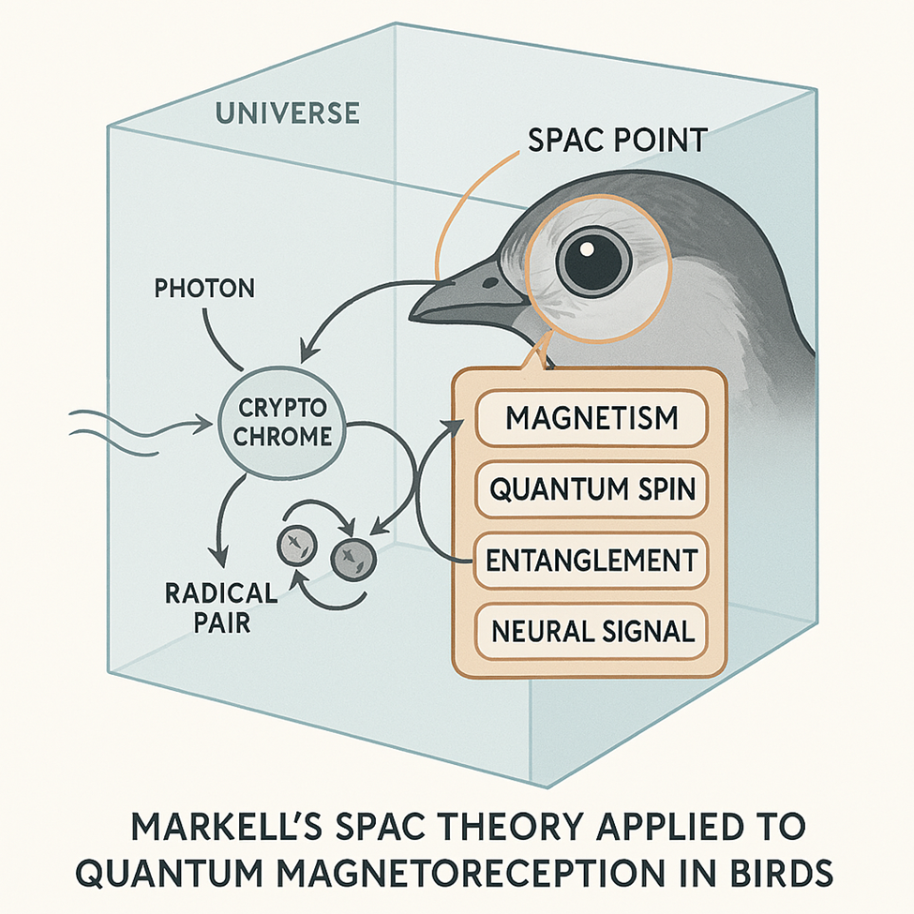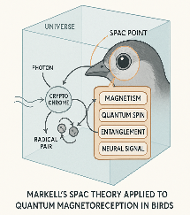

A Digital Portal Into Our Understanding Of The Universe

Imagine a giant translucent outline of a cube surrounding the entire universe. Imagine further, that a single point is highlighted inside this cube, and of a represented axis location “x” “y” and “z”. This single point is static, is almost infinitely small and it is a point that encloses a three-dimensional space within its confines that is hypothetically similar to a three-dimensional chessboard. The three-dimensional chessboard is made up of a hypothetical eight by eight by eight grid, a total 512 positions. In each one of the hypothetical 512 points of this grid is a unique sensor. Some of these sensors we might know and understand as to what they measure, such as; gravity, magnetism, temperature, and various aspects of time, and so on. Other sensors we may not know and have yet to be discovered or understood. Each one of these sensors registers a digital value respective of the entity it is sensing whether it be gravity, magnetism, weak force, strong force etc..
Imagine that the location of this individual point is graphically represented through the faces of the cube by imaginary lines passing through the translucent outlined cube. This highlighted point is just one of a near infinite number of points within the universe. Let one of these points be called a SPAC, Spatial Point of Acute Conceptualization.
Imagine now, that the big bang is located somewhere within this giant translucent outline of a cube, as well as various galaxies, planets, dark matter and other known and unknown entities. As aforementioned bodies occupy (or pass through) this individual point (SPAC) at light speed, any speed, or no speed, this single SPAC registers sensor values. And so it is with all the near infinite number of other SPACs that fill this cube, comprising the universe. Each SPAC being graphically and numerically located by the translucent outlines of this cube.
Now imagine that this single SPAC is not only located by just the three lines passing through the faces of the cube, but by one or more than one, determined, or not determined other locators. Possibly extra- dimensional locators, passing line(s) or other geometric shapes, outward from this single point. Possibly a person could represent or visualize one or more of these extra-dimensional lines possibly as flat planes, visually unconnected to the translucent cube but represented by a numerical matrix value of “a” and “b” axis and so on for each multiple extra dimensional locators such as “c” and “d” etc..
Visualize that each unique SPAC with extra dimensional locational faces such as “a” and “b”, is repeated almost infinitely throughout this vast cube that encompasses the entire universe.
For speculation assume that as a human we may occupy and register a reading on only fifty of the 512 registers on a single SPAC. These fifty could fully define a living human being. But let us assume that there are other beings or energies that register differently than us. Possibly on sixty to eighty of the 512 sensors, but not necessarily the same ones as us. Possibly these other beings are made up of energy and matter that can occupy the same exact place as a living human, and we would be unaware, or possibly only aware in unusual circumstances and through indirect evidence. For instance, a brief apparition of a loved one near death, a mass flight of animals from an impending tsunami, a family pet performing extraordinary feats to rescue its master. We might be totally unaware of theses entities as they register values on the same SPACs that we occupy.
For the remainder of this essay, REGARDING OCCURENCES ON EARTH, let us adjust our perception of the SPACs and consider them in sync and static to the rotation of the earth.
The time that we know and exist within, registers from the clocking of the big bang and rotation of the earth. This time could be represented on one or more of the 512 registers on the SPACs, or possibly on a whole layer of the SPACs. If other energies or entities comprise readings on sixty to eighty of the registers on a SPAC, rather than just the fifty hypothetical registers that we occupy, is it possible that time is different for them? Could these energies or beings act as if in hyper-time compared to us? For example, assume that you are walking down the sidewalk and an intelligent energy is occupying some of the same space as you. Unbeknownst to you, a piece of sheet metal is falling to the ground from an airplane that passed overhead. For some reason you stop and decide to look at a squirrel making a lot of noise on a nearby tree. A split second later, the piece of sheet metal impacts the ground where you might have been if not for the noisy squirrel. Could this intelligent entity operating at a much higher speed in time, have coerced the squirrel to make noise, and cause you to pay attention to the unusual action of the squirrel by interacting with the registers on your SPACs and the squirrel's?
As a further example, imagine that you have a twenty-gallon fish aquarium on a table with several goldfish swimming inside. Now imagine that you place your hand into the tank to pick up a fish toy from the bottom of the tank. Of course, the displacement of your hand causes the water to rise, and the fish wonder what this “thing” is, that entered the water. Now imagine that instead of physically placing your hand into the fish tank, you have a powerful magnetic machine that replicates the movements of your hand. As you gently wave your replicated hand through the aquarium and through a fish, you can't see the magnetic copy of your hand, but you know it is there. The fish however, has no idea that a magnetic hand has just co-existed and passed through its body.
Hypothesizing into the future that science develops the technology to not only control the magnetic process described above but has enhanced it to the point that other energy phenomena can be carried along this magnetic wave just as multiple digital and analog information is carried through radio waves. As the magnetic hand passes through the fish, other energies might be piggybacked, and for instance heal genetic defects in the fish. Possibly you see a bigger fish camouflaged ahead, and ready to bite the goldfish. You press a button on your magnetic replicated hand that causes a scare to the goldfish, and it darts away averting capture by the camouflaged fish. These scenarios would take place with the fish being totally unaware of the energies and efforts of beings unknown to itself. If the hypothetical magnetic energy phenomena passing through the fish involved high speed computer driven algorithms that diagnosed and healed, or scared the fish when danger was perceived, that procedure might be considered to be operating at hyper-speed, relative to the goldfish in its time. In the previous example a person walking down the street pauses to look at a noisy squirrel. That example might seem analogous to the fish in the tank. Both involved unknown energies, operating within the same space.
In the above example, our goldfish and humans might register values on possibly the same fifty registers of a SPAC. Yet we have affected the registers relating to magnetism, and the fish is unaware. In possibly a freak occurrence during the fish's lifetime, the aquarium might contain a very high content of iron from a change of water when cleaning the aquarium. In that rare occurrence the fish might glimpse the magnetic hand. But it only sees the hand, it doesn't know that some genetic defects within itself had been repaired or that another being scared it and saved its life. I believe that we also witness freak events that we don't understand and that through a digital method of discovery by testing, indirect evidence, anomalies, anecdotal and anachronistic oddities we may further discern more of the cosmos.
Summary
There are numerous articles of family pets like dogs, parrots, and even potbellied pigs doing unbelievable tasks to save their masters. In my own case I have witnessed things that are inexplicable. Some of these things might be dismissed as luck or, “...that's the way it goes...” But many of these occurrences would seemingly take not only some supernatural phenomenon, but an entity that could recognize a situation with prescience (or hyper time relative to us) and then somehow move quickly in relationship to our human clocked time.
I have several children and two of them are identical twins. There are multiple fascinating stories of “twin power,” in my family. One incident happened when they were about ten years old. One of the twins was in the kitchen while the other twin was with another sister about a half block away. The twin in the kitchen cried, “Ouch!” and reached down and grabbed her leg for no reason. Shortly thereafter, the other twin and sister came in and reported that a big dog down the street had bitten the twin in the leg. Could the SPACs I described evidence a reading on one of the 512 sensors that is a harmonic energy source reading between twins? Is it possible that an unknown energy can activate readings on other than the hypothetical fifty human registers of a SPAC? Now the twins, adults and separated by a thousand miles, still share strange feelings from remote experiences that occur.
Another relative had a very nice and reliable watch. Two times it stopped at the exact minute a close relative died. It seems like a very unlikely happening. Could there also be a time and energy connection on additional registers of SPACs? Some individuals seem to be born lucky and have won lotteries numerous times. Professional people put their careers on the line every year by reporting unexplained phenomenon they've personally witnessed. Is it by random luck, as iron being added to the aquarium that allowed these unexplained things to be discerned? Could these unexplained phenomena be partially reconciled by the description of SPACs? My mother and her sister both suffered from breast cancer. The length of their illnesses varied by several years, yet they died at the exact same minute, two hundred and fifty miles apart in different hospitals. What sort of energy or entity could influence this? My wife's aunt was at the deathbed of her husband. She saw an apparition of a woman in white appear and say, “Come on Tedor, You can come with me now.” For years the aunt never said anything about the incident, until she saw a photo of Ted's mother for the first time. The woman looked just like the apparition. Upon further explanation of the story, Ted' s older sister exclaimed, “Tedor... that's what my mother called Ted.” The aunt was totally unaware of the nickname. Could the apparition be explained by energies that co-exist with us, but are values that register on different portions of the SPACs that we as living humans are aware? Could it be that upon death, a certain energy is released, that in effect acts as iron being added to the aquarium and making visible a magnetic hand, or in this case, a view to another part of the universe that is unknown to us?
Many discoveries are of unexpected phenomena, welcome byproducts of the original focused intent. These discoveries are aided by the advance of science in general, but shouldn't we also pursue a strategy to discover it all, in a non-focused intent? As computers become more and more powerful, and technology advances, it is time to look at the universe in a perspicacious way, right here on earth. Serendipitous discoveries of computer recognized anomalies might transcend single focused science and expand our understanding of the cosmos. There are many unknown events in our daily lives that people sometimes dismiss as; luck, a miraculous event, that was weird, etc.. Computer processing could lead the way in connecting these phenomena if we look at a microcosm of the universe as a puzzle solving endeavor, or even as an art.

